Contribution Title (max. 3 lines, Times New Roman (TNR), 16pt, bold, left justified)
Name of First Author¹ and Ioanna Papayianni² (TNR, 10pt, bold, left justified)
¹ Affiliation of the first author, country, e-mail, one per line (TNR, 8,5pt, left justified)
² University of xxxx, Greece, e-mail@xxx.com
Abstract (TNR, 10pt, justified on both sides, spacing before and after 24pts). Each paper should be preceded by an abstract (10–15 lines long) that summarizes the content. The length of the contribution should be between 6 to 8 pages. Page format is A4, margins 46mm left, 47mm right, 52mm top and 57mm bottom. All papers must be written in English. If you are not confident in your ability to write in English please ask an English native speaker to proofread your paper before submission.

Heading level 1 (TNR, 12pt, numbered, bold, left justified, text indented hanging 0.76 cm)
Please use the decimal system of headings with no more than three levels.

Level 2 (TNR, 12pt, numbered, bold, italic, left justified, text indented hanging 1.02 cm)

Level 3 (TNR, 10pt, numbered, bold, left justified, text indented hanging 1.27 cm)

Writing Your Text
Use Times New Roman font for the entire text. (10pt, justified on both sides. Each paragraph has first line indented 0.42 cm). No space between paragraphs. Please use this Word template to prepare your text. All the necessary formatting is already preset in the template. In running text, please set emphasized words or phrases in italic type. Please keep to the manuscript length of maximum 8 pages.
Lists have bullet points and 6pt space above and below. Please avoid the following:
- do not divide words at the end of lines
- do not use colour or shading in text or tables
do not include footers.

Technical Terms, Abbreviations
Ensure that the spelling of names, terms, and abbreviations is consistent, including in tables and figure legends. Abbreviations, except for very commonly ones, must be defined the first time they are used. Please always use internationally accepted signs and symbols for units, so-called SI units. Chemical compounds should be named according to the systematic rules of the IUPAC or Chemical Abstracts. Please also note that species and genus names, mathematical/physical variables, and prefixes in chemical compounds should be set in italic type (cis/trans, d/l, E/Z, o/m/p, R/S, t-Bu, tertbutyl).

Tables
Number the tables consecutively using the table number (e.g., Table 1) and ensure that all the tables are cited in the text in the correct order. Give each table a caption placed above it. Do not use the space bar to separate columns, and do not use Excel to create tables. If a table cell is to be left empty, please type a hyphen ( - ) in it. Please do not treat simple, one-column lists as tables, but instead set them as part of the running text.
Table 1 Table caption (TNR, 8.5pt, left justified, spacing 12pt before and 6pt after)
Column 1 | Column 2 | Colum 3 | Colum 4
Peter* | 185 | 8 | -
Paul | 190 | 9 | -
* Text in table cells should be TNR 8.5pt, left justified.

Figures and Illustration Data
Please include figures directly into the text. Each figure should have a concise caption describing accurately what the figure depicts. Number the figures consecutively. See example in Fig. 1. Minimum required resolution for photographs and halftone arts is 300dpi. Optimal is 600dpi.

Line Art Black and white graphic with no shading
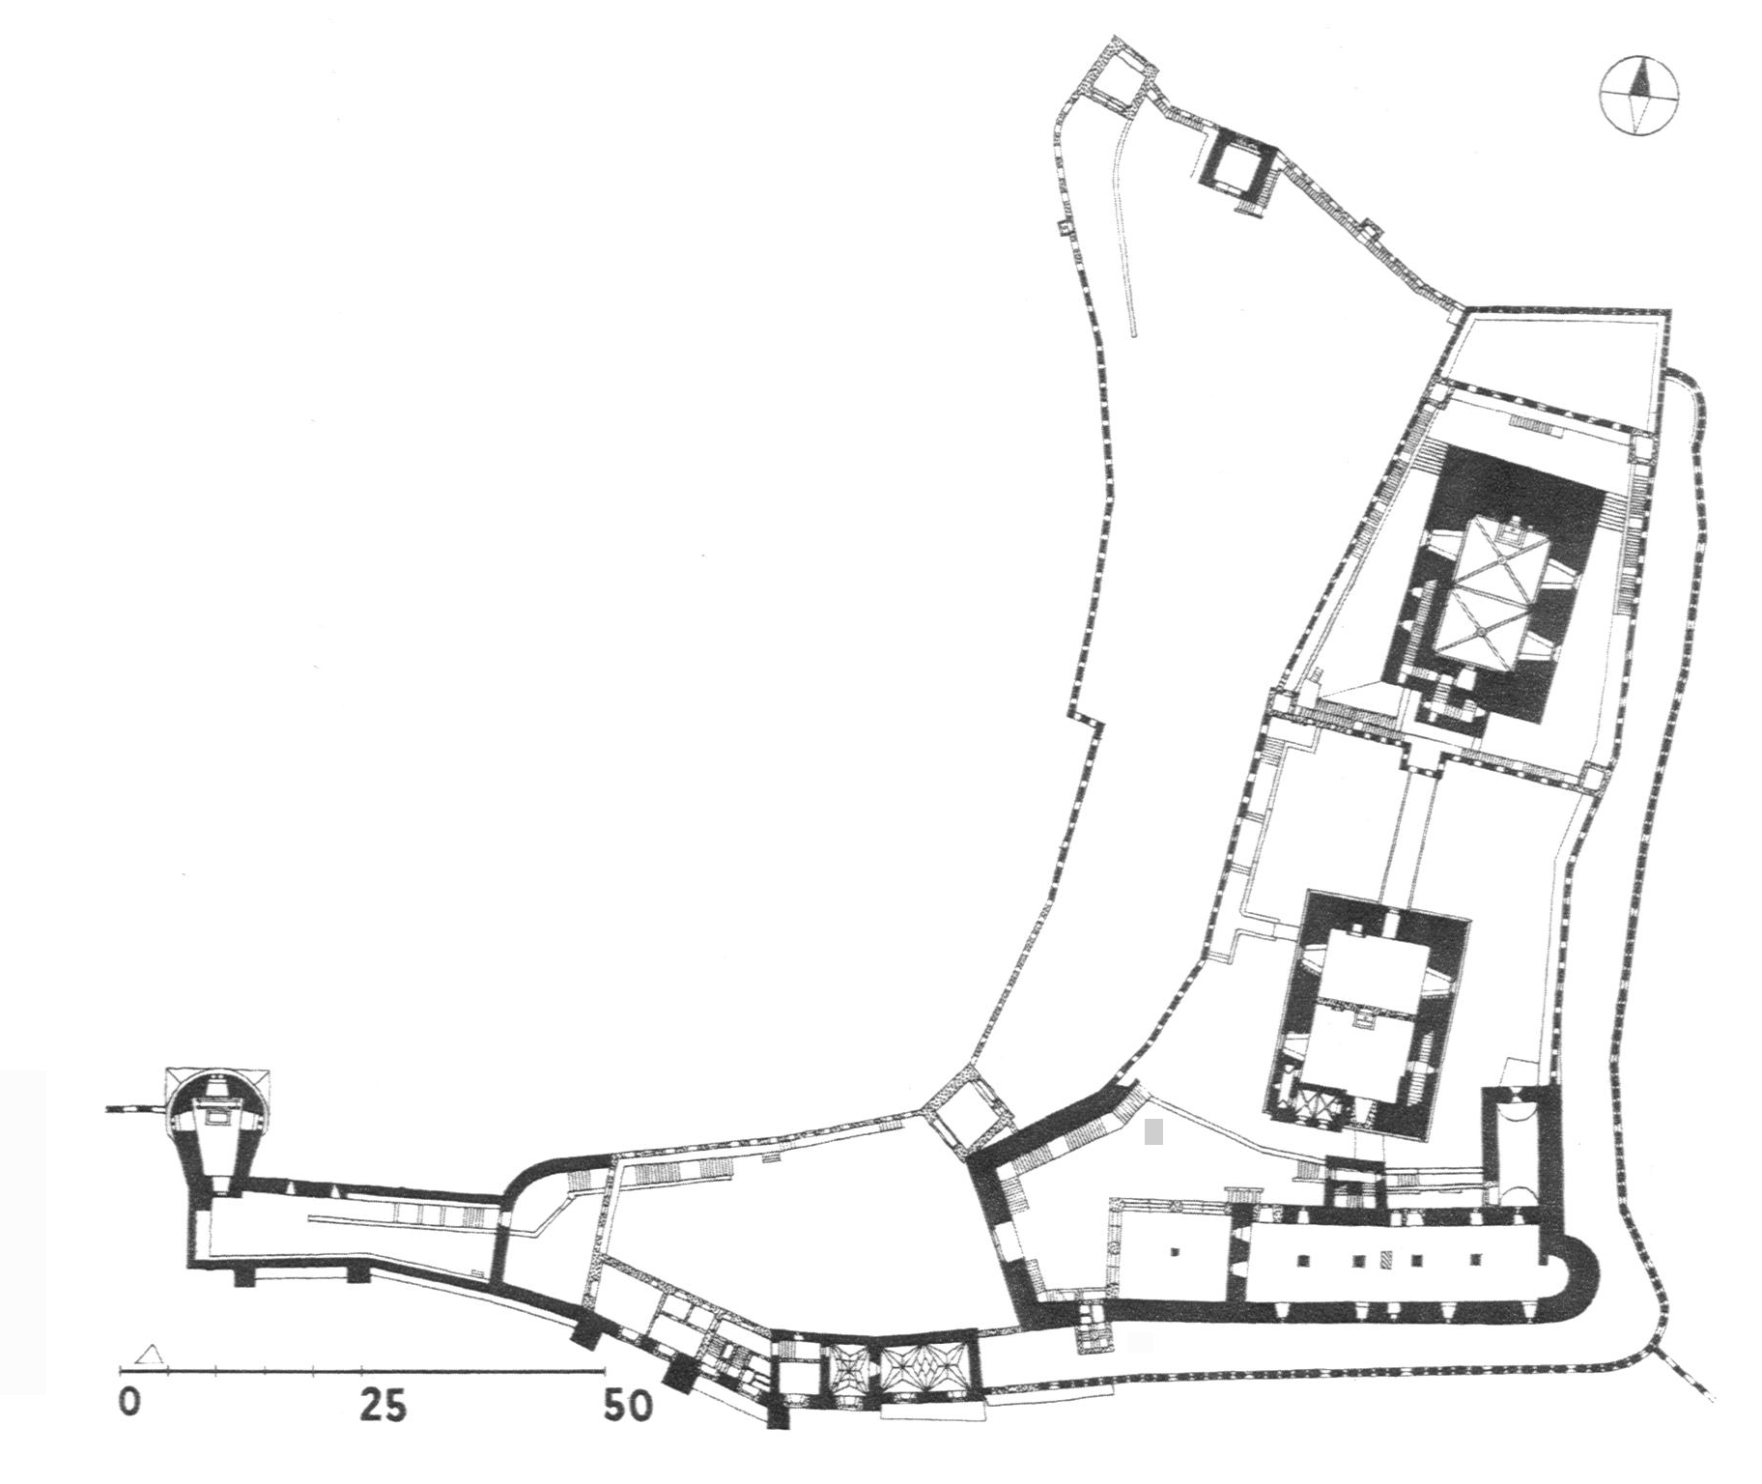
- Check that all lines and lettering within the figures are legible at final size. All lines should be at least 0.1 mm (0.3 pt) wide.
- Line drawings should have a minimum resolution of 1200 dpi.
- Vector graphics containing fonts must have the fonts embedded in the files.

Fig. 1 Example of figure (TNR, 8,5pt, numbered, centre justified)

Equations
Equations of the type a2+b2=c2 can be written as normal text. For all other equations, please use MathType or the Microsoft equation editor, and insert the graphic into your text file as an object. Prepare the whole equation in this way and not just part of it.
- Do not insert the equation number from the equations editor.
- Please do not insert symbols or special characters that are not part of equations as graphics or using the formula editor if they are available as Symbol or Unicode fonts.
- The formula number is given in parentheses as right aligned text next to the formula. When writing the formula, press tab and enter the equation. Then press tab again and type the equation number manually.
${\left(a+b\right)}^{2}=a^{2}+2\text{ab}+b^{2}$ (1)
- If the equation is part of a sentence, the equation itself should end with a punctuation mark (not after the equation number).

References
References are cited in the text using reference numbers in square brackets sequential by citation [3, 7, 12].
Journal article
- (TNR, 8,5pt, left justified, indentation hanging 0.42cm)
- Smith J, Jones M Jr, Houghton L et al (1999) Future of health insurance. N Engl J Med 965:325–329
Journal article only by DOI
- Slifka MK, Whitton JL (2000) Clinical implications of dysregulated cytokine production. J Mol Med. doi:10.1007/s001090000086
Book
- South J, Blass B (2001) The future of modern genomics. Blackwell, London
Book chapter
- Brown B, Aaron M (2001) The politics of nature. In: Smith J (ed) The rise of modern genomics, 3rd edn. Wiley, New York
Online document (no DOI available)
- Marshall TG, Marshall FE (2003) New treatments emerge as sarcoidosis yields up its secrets. ClinMed NetPrints. http://clinmed.netprints.org/cgi/content/full/2003010001v1. Accessed 24 June 2004
- Please do not put commas between names and initials, and do not put periods after initials or abbreviations.
- Always use the standard abbreviation of a journal's name according to the ISSN List of Title Word Abbreviations, see http://www.issn.org/en/node/344.

Sources
If you copy text passages, figures, or tables from other works, you must obtain permission from the copyright holder (usually the original publisher) for both the print and online format. Please enclose the signed permission with the manuscript. Please be aware that some publishers do not grant electronic rights for free. In such cases, material from other sources should be used. The source must be acknowledged in the legend or table heading. If the source is in a foreign language, please provide a translation.

